Week 6
Module 10

Prb3:
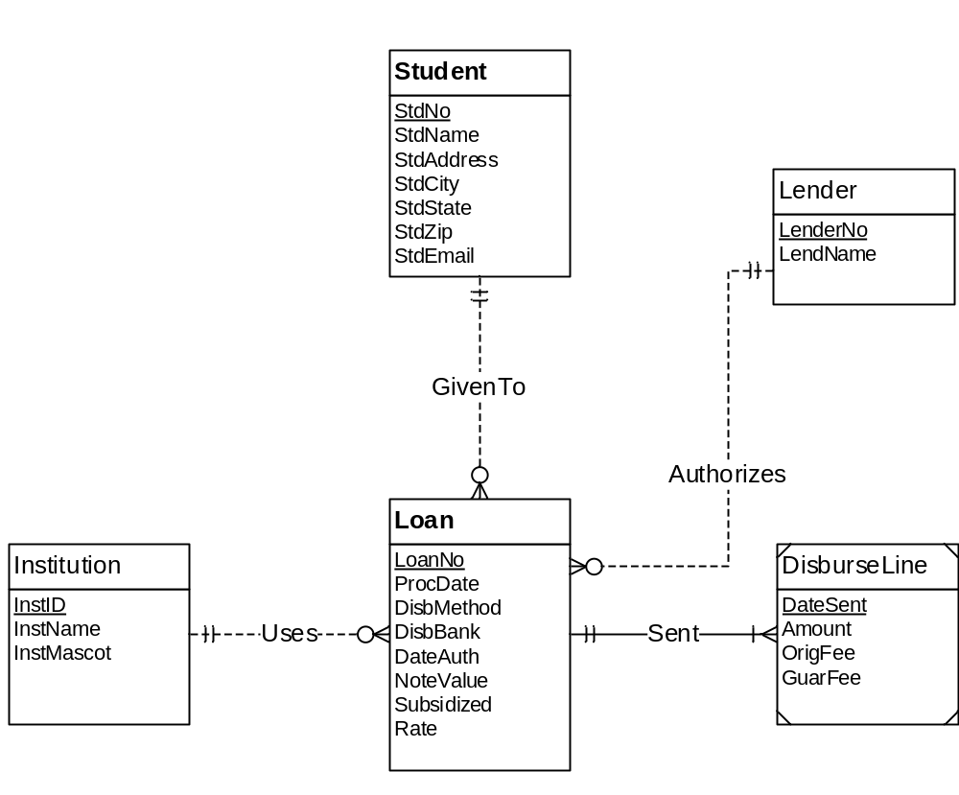

Student (StdNo, StdName, StdAddress, StdCity, StdState, StdZip, StdEmail)
Institution (InstID, InstName, InstMascot)
Loan (LoanNo, ProcDate, DisbMethod, DisbBank, DateAuth, NoteValue, Subsidized, Rate, StdNo, InstNo, LenderNo)
FOREIGN KEY(StdNo) REFERENCES Student
FOREIGN KEY(InstNo) REFERENCES Institution
FOREIGN KEY(LenderNo) REFERENCES Lender
StdNo NOT NULL
InstNo NOT NULL
LenderNo NOT NULL
Lender (LenderNo, LendName)
DisburseLine (DateSent, LoanNo, Amount, OriFee, GuarFee)
FOREIGN KEY(LoanNo) REFERENCES Loan
LoanNo NOT NULL

Note : No M-N relationship is here

